HOW TO USE THE GATEWAY TO ASTRONAUT PHOTOGRAPHY
http://eol.jsc.nasa.gov/

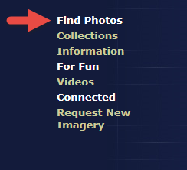
Step One : Click on “Find Photos” and drag across to “Find Photos Main Page.”
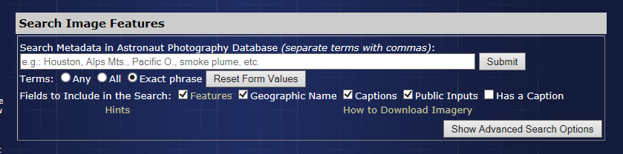
One way to find an image is to enter the name of the location in the “Search Metadata Box.” In the area that says “e.g: Houston. . . “ Type “Duxbury, Massachusetts” without the quotes.
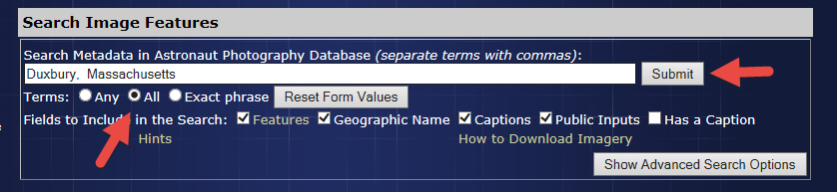
Click on the “All” button. Then Click on “Submit.”
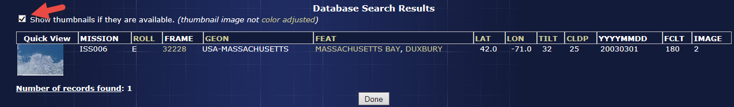Click on the box that says “Show thumbnails . . . “ Then click on the thumbnail itself.
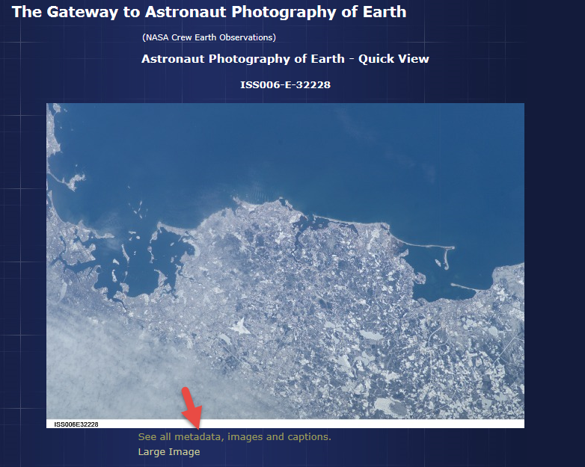
Click on “See all metadata . . .”
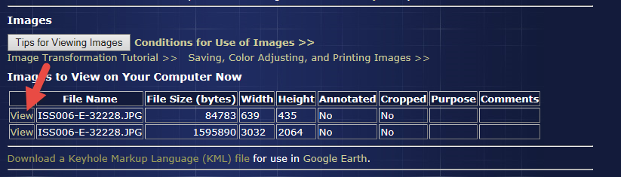
Under the image is a huge amount of information. The first important piece shows you two view choices for seeing the image. You can select either. The top is usually smaller than the bottom. In this case small = 639 x 435 pixels. Click on that view.
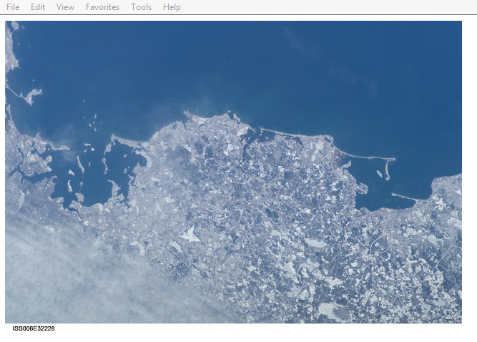
It shows you the image. Nothing has been done to these images. They are as they were when they came out of the camera. You can save the image if you want it by right clicking on it. Put it into whatever software you use to make corrections. Or you can do no corrections. Go back to the previous screen.
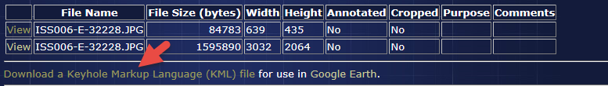
If you have Google Earth installed, and you click on “Download a Keyhole Markup Language . . .” You will find the exact location in Google Earth!
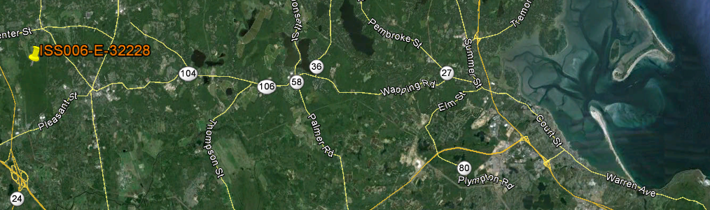
Why go to Google Earth? First, you can find the orientation of your image, and see where “North” is. Second, you can make measurements in Google Earth.
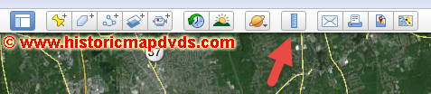
The measurement tool is at the top. If you click on it . . .

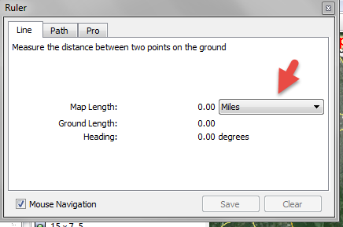
. . . You can click on the “Miles” drop down box and change it to whatever measurement type you want. Then you can draw a line between two points . . .
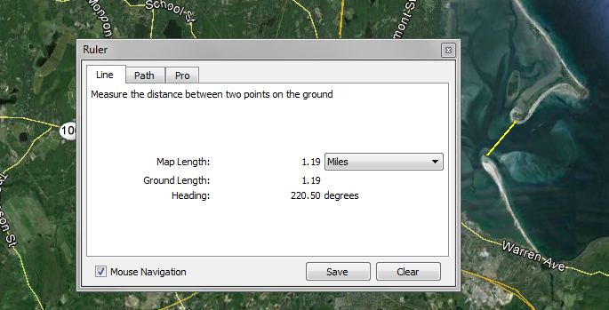. . . and it will give you the length in whatever scale you selected.
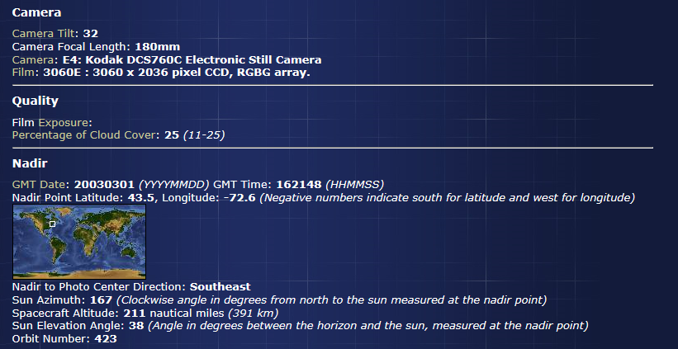
The next important section is the “Camera” section. “Camera tilt” is how far from perpendicular the image is. Why is this important? The greater the angle, the greater the distortion of the image will be. This is very important if you are making measurements. The greater the angle, the lower the accuracy of your measurement will be. “Camera Focal Length” (180mm in this case) is the size of the lens the astronaut used to take the photograph.
“Quality” is the amount of cloud cover. “Nadir” is the spot directly under the spacecraft. There is a huge amount of statistical data under “Nadir” that may, or may not be important to your study.
FINDING IMAGES USING THE CLICKABLE MAP
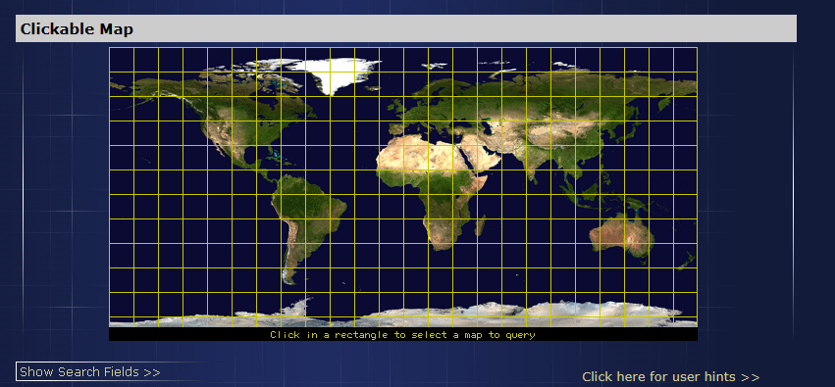
Go back to Find Photos and select the “Clickable Map.” Click on some place on the map you want to visit.
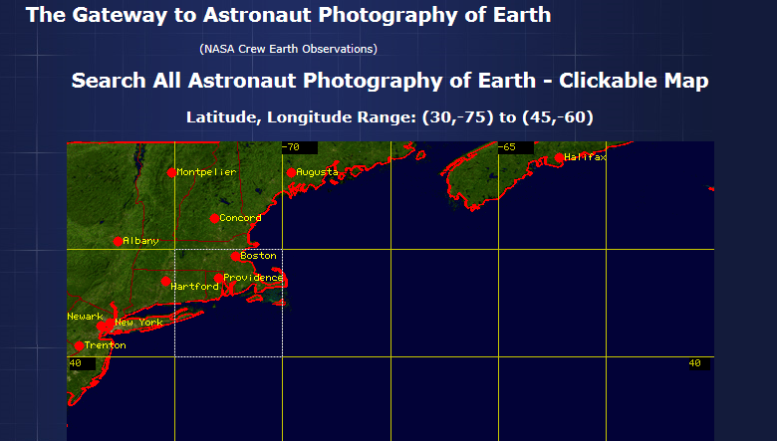
I clicked on a spot near Massachusetts, and this came up. If you messed up . . .
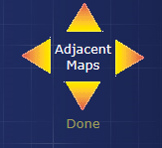
Click on the “Adjacent Map” tool until you get where you want to be. When your happy with the general location, click on the exact spot on the map where you want to go, and this comes up:
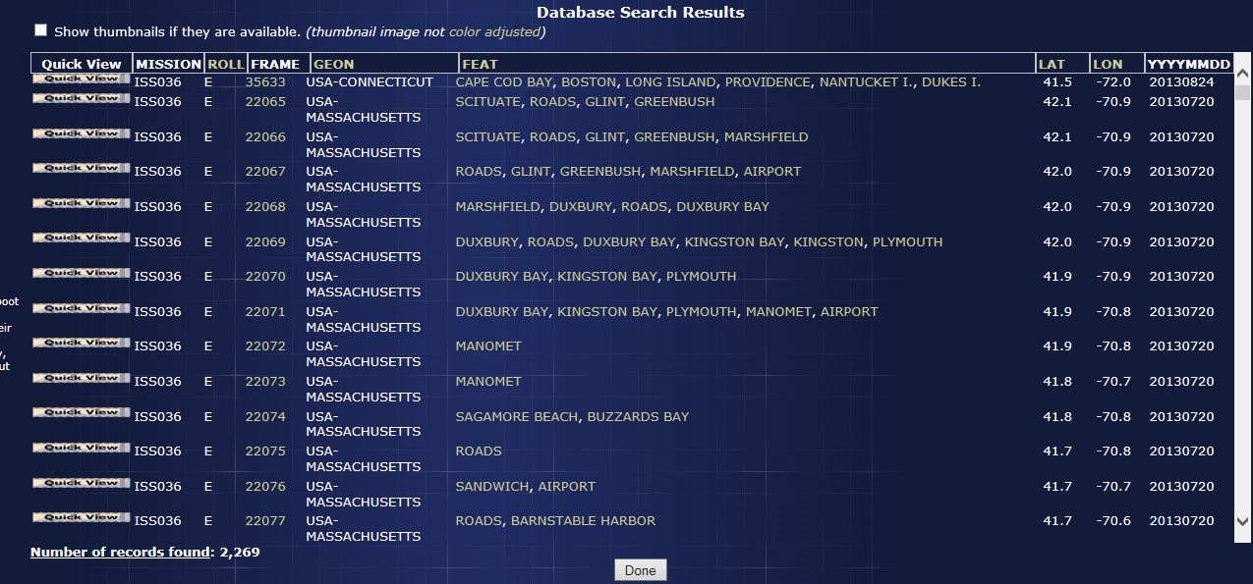
Find what you want. Everything after that is the same as using “Search Image Features.”

